**iSelect – Coding Challenge**

* This console application is a simulation of a robot moving on a square table top, of dimensions 5 units x 5 units.
* Robot will start moving when first command ‘PLACE’ is issued.
* Once the robot started moving any valid commands like ‘MOVE’ , ‘LEFT’, ‘RIGHT’ or ‘PLACE’ can be issued.
* Invalid commands are ignored
* Commands that will make robot to fall from the table top are not activated.
* MOVE will move the robot one unit forward in the direction it is currently facing.
* LEFT and RIGHT will rotate the robot 90 degrees in the specified direction without changing the position of the robot.
* REPORT will announce the X,Y and F of the robot by writing the value to program console.
* Input is a text file. There are 3 input files are submitted wit this

RobotCommands_1.txt ( with all valid commands)

RobotCommands_2.txt ( with invalid commands)

RobotCommands_3.txt ( only invalid commands)

* Error handling is implemented

**Technology used:**

* .NET Core Framework 2.0.0
* C#
* Microsoft.Extensions.DependencyInjection
* Xunit

**How to run the applications on windows command prompt**

1. Please copy and extract erosha.zip
2. Open windows command prompt
3. Navigate to ..\Erosha\Publish path
4. Run TableTopRobot.dll with any input file as an argument

Ex:

Run >dotnet TableTopRobot.dll C:\iSelect\Erosha\Input\RobotCommands_1.txt

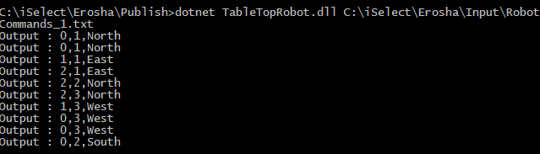

**How to run the application or examine the code using Visual Studio**

1. Open Visual studio 2017 ( with .net core Framework 2.0)
2. Open the solution from …Erosha\ TableTopRobot.sln
3. There are 2 projects on TableTopRobot solution

TableTopRobot – Console application to move the robot with valid commands

TableTopRobotTest – xunit Test project

1. Debug to TableTopRobot project to run the console application
2. Use Test Explorer to run the TableTopRobotTest project.
3. Project technical design structure as follows

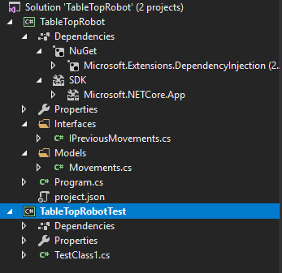

1. Ext Explorer:

